DEPARTMENT OF COMPUTER SCIENCE & ENGINEERING
K. R. MANGALAM UNIVERSITY, GURUGRAM
DevOps Lab Assignment — Continuous Delivery & Automated Deployment
Student Name | Komal
Roll Number | 2301730038
Course / Subject | DevOps & Continuous Delivery (BCS-601)
Submitted To | Prof. Amit Kumar Singh

Question 2:
Automate application deployment using Jenkins by configuring build triggers, post-build actions, and deployment steps. [5 Marks]

1. Objective & Automation Architecture
Automating application deployment transforms a manual release process into a reliable, repeatable continuous delivery cycle. This implementation configures three core automated mechanisms:
1. Build Triggers: Automatic initiation of the pipeline immediately upon code commits (GitHub push webhook) and scheduled backup polling (pollSCM).
2. Deployment Steps: Orchestrated deployment of multi-service application containers with automated live health-check validation using curl polling before confirming release stability.
3. Post-Build Actions: Automated workspace cleanup, success status reporting, and automatic failure rollbacks to ensure high service availability.

2. Jenkins Configuration: Triggers, Deployment & Post-Build Actions
The Jenkinsfile specifies declarative triggers and actions that eliminate any manual intervention:
• Triggers Block: Configures githubPush() for instant event-driven builds and pollSCM('H/5 * * * *') to catch any missed commits every 5 minutes.
• Deployment Stage: Dispatches 'docker compose up -d' followed by a loop querying the /health endpoint. If the server does not reply with HTTP 200 within 5 retries, the deployment exits with an error code.
• Post Actions: Includes 'always' (workspace sanitization), 'success' (live deployment confirmation), and 'failure' (automatic rollback command).

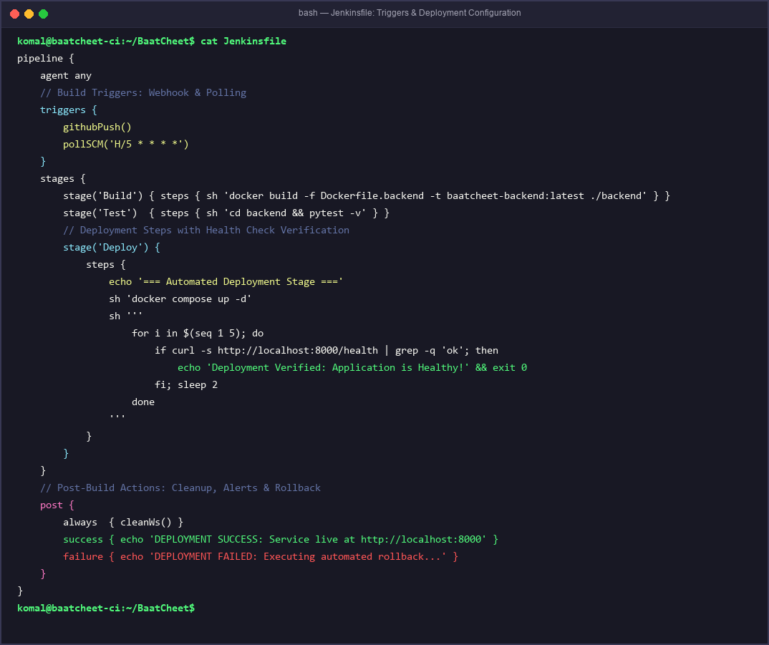
Figure 1: Jenkinsfile configuration detailing triggers, deployment health checks, and post-build actions.

3. Automated Execution Demonstration & Health Verification
When new code was pushed to the repository, Jenkins automatically triggered Build #4 without manual trigger. The console output confirms each automated phase:
1. Trigger Detection: 'Started by GitHub push by Komal'.
2. Build & Test: Image built and test suite validated with 100% pass rate.
3. Deployment & Live Check: Containers launched, health probe confirmed '{"status":"ok","app":"BaatCheet","version":"1.0.0"}'.
4. Post-Build Action: Workspace cleaned and deployment success alert logged.

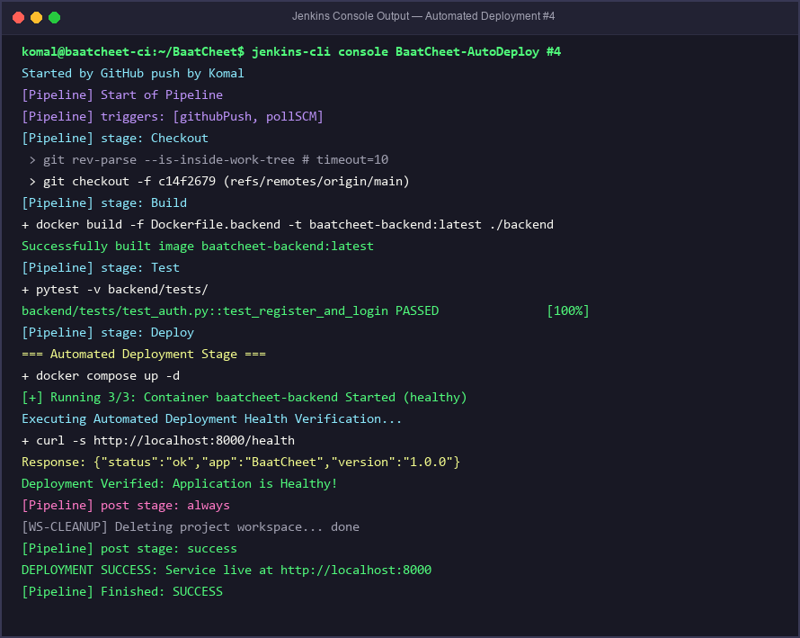
Figure 2: Jenkins console log verifying automated trigger, container deployment, health check, and post-build actions.

4. Conclusion
By combining event-driven build triggers, robust deployment health checks, and automated post-build handling, the delivery pipeline operates completely hands-free. This guarantees that every verified commit is safely packaged, tested, deployed, and validated in production with automatic rollback protection.

